**A**

**PROJECT REPORT**

**ON**

**“Dairy Mate”**

**SUBMITTED TO**

**SHIVAJI UNIVERSITY, KOLHAPUR**

**IN THE PARTIAL FULFILLMENT OF THE REQUIREMENT**

**FOR THE AWARD OF DEGREE**

**BACHELOR OF TECHNOLOGY IN COMPUTER SCIENCE AND ENGINEERING**

**SUBMITTED BY**

|  |  |  |
| --- | --- | --- |
| **MR.** | **Namit Pramod Patil** | **23UAD304** |
|  |  |  |
|  |  |  |

**UNDER THE GUIDANCE OF**

**Mr. S. P. Pise**

 



**DEPARTMENT OF ARTIFICIAL INTELLIGENCE AND DATA SCIENCE ENGINEERING**

**DKTE SOCIETY’S TEXTILE AND ENGINEERING INSTITUTE, ICHALKARANJI**

**(AN EMPOWERED AUTONOUMOUS INSTITUTE)**

**2024-2025**

**D.K.T.E. SOCIETY’S**

**TEXTILE AND ENGINEERING INSTITUTE, ICHALKARANJI**

**(AN EMPOWERED AUTONOUMOUS INSTITUTE)**

**DEPARTMENT OF ARTIFICIAL INTELLIGENCE AND DATA SCIENCE ENGINEERING**



**CERTIFICATE**

**This is to certify that, project work entitled**

**“Dairy Mate”**

**is a Bonafide record of project work carried out in this college by**

|  |  |  |
| --- | --- | --- |
| **MR.** | **Namit Pramod Patil** | **23UAD304** |
|  |  |  |
|  |  |  |

**is in the partial fulfillment of award of degree Bachelor of Technology in Artificial Intelligence and Data Science Engineering prescribed by Shivaji University, Kolhapur for the academic year 2024-2025.**

**MR. S. P. PISE**

**(PROJECT GUIDE)**

**PROF. (DR.) T. I. BAGBAN PROF.(DR.) L.S. ADMUTHE**

**(HOD AI & DS DEPT.) (DIRECTOR)**

**EXAMINER: ________________**

**DECLARATION**

We hereby declare that, the project work report entitled “Dairy Mate” which is being submitted to D.K.T.E. Society’s Textile and Engineering Institute Ichalkaranji, affiliated to Shivaji University, Kolhapur is in partial fulfillment of degree B.Tech.(AI & DS). It is a bonafide report of the work carried out by us. The material contained in this report has not been submitted to any university or institution for the award of any degree. Further, we declare that we have not violated any of the provisions under Copyright and Piracy / Cyber / IPR Act amended from time to time.

|  |  |  |  |
| --- | --- | --- | --- |
| **Title** | **Name of the Student** | **PRN** | **Signature** |
| MR. | Namit Pramod Patil | 23UAD304 |  |
|  |  |  |  |
|  |  |  |  |
|  |  |  |  |

**ACKNOWLEDGEMENT**

With great pleasure we wish to express our deep sense of gratitude to Mr. S. P. Pise for his valuable guidance, support, and encouragement in the completion of this project report.

Also, we would like to take the opportunity to thank our head of department Dr. T. I. Bagban for his cooperation in preparing this project report.

We feel gratified to record our cordial thanks to other staff members of the Artificial Intelligence and Data Science Department for their support, help, and assistance which they extended as and when required.

Thank you,

|  |  |  |
| --- | --- | --- |
| **Title** | **Name of the Student** | **PRN** |
| MR. | Namit Pramod Patil | 23UAD304 |
|  |  |  |
|  |  |  |
|  |  |  |

**ABSTRACT**

The Dairy Mate project presents an innovative web-based Dairy Management System designed to revolutionize traditional dairy operations through digital transformation. This system addresses the critical challenges faced by dairy businesses in managing milk collection, user data, and financial transactions efficiently.

The primary objective of Dairy Mate is to streamline the daily operations of dairy businesses by providing a comprehensive platform that connects dairy farmers and administrators. The system features a dual-interface architecture with distinct admin and user dashboards, enabling efficient management of milk collection records, real-time monitoring of fat percentages, and automated calculation of payments based on current rates.

The system is built using modern web technologies including Node.js, Express.js, and MySQL, ensuring robust performance and scalability. The implementation of responsive design principles ensures accessibility across various devices, making it practical for both field and office use.

Dairy Mate significantly reduces manual record-keeping errors, enhances transparency in transactions, and improves the overall efficiency of dairy operations. The system's successful implementation demonstrates its potential to modernize traditional dairy management practices while providing a user-friendly interface for all stakeholders involved.

**Keywords:** Dairy Management System, Milk Collection, Fat Percentage Tracking, Real-time Monitoring, Web Application, Node.js, Express.js, MySQL

**INDEX**

1. **Introduction** 1
   1. Problem definition 1
   2. Aim and objective of the project 2
   3. Scope and limitation of the project 3
2. **Background study and literature overview** 5
   1. Literature overview 5
   2. Investigation of current project and related work 6
3. **Requirement analysis** 9

a. Requirement Gathering 9

b. Requirement Specification 10

c. Use case Diagram 11

1. **System design** 12
   1. Architectural Design 12
   2. Flow Chart 12
   3. System Modeling 13
      1. Dataflow Diagram 13
2. **Implementation** 14

a. Agile Methodologies 14

b. Development Model 15

1. **Future Scope** 17
2. **References (Public repository GitHub source code links)** 18

**1. Introduction**

1. **Problem definition**

The dairy industry faces several critical challenges in its traditional management approach:

1. **Manual Record Keeping**

* Prone to human errors in recording milk quantities and fat percentages
* Time-consuming process of maintaining physical ledgers
* Risk of data loss or damage to physical records
* Difficulty in tracking historical data and generating reports

1. **Payment Calculation Complexities**

* Complex calculations based on varying fat percentages
* Manual computation of payments leading to errors
* Lack of transparency in rate application
* Time delays in payment processing

1. **Communication Gap**

* Inefficient communication between dairy administrators and farmers
* Difficulty in accessing personal collection history
* Lack of real-time information about current rates and payments
* No centralized system for information sharing

1. **Data Management Issues**

* Scattered information across multiple registers
* Difficulty in maintaining user profiles and histories
* Challenges in generating periodic reports
* Inconsistent record formats

1. **Aim and objective of the project**

The dairy industry faces several critical challenges in its traditional management approach:

1. **Manual Record Keeping**

* Prone to human errors in recording milk quantities and fat percentages
* Time-consuming process of maintaining physical ledgers
* Risk of data loss or damage to physical records
* Difficulty in tracking historical data and generating reports

1. **Payment Calculation Complexities**

* Complex calculations based on varying fat percentages
* Manual computation of payments leading to errors
* Lack of transparency in rate application
* Time delays in payment processing

1. **Communication Gap**

* Inefficient communication between dairy administrators and farmers
* Difficulty in accessing personal collection history
* Lack of real-time information about current rates and payments
* No centralized system for information sharing

1. **Data Management Issues**

* Scattered information across multiple registers
* Difficulty in maintaining user profiles and histories
* Challenges in generating periodic reports
* Inconsistent record formats

1. **Scope and limitation of the project**

**Scope**

1. **System Coverage**

* Complete milk collection management
* User profile management
* Payment calculation system
* Report generation
* Rate management
* Real-time data updates

1. **User Categories**

* System administrators
* Dairy farmers (users)

1. **Functionality**

* Daily milk collection recording
* Fat percentage tracking
* Payment calculation
* Report generation
* Profile management
* Rate management

**Limitations**

1. **Technical Limitations**

* Requires internet connectivity for real-time updates
* Limited to web browser access
* Dependent on server availability
* No offline mode functionality

1. **Functional Limitations**

* No integrated payment gateway
* No mobile application support

1. **Operational Limitations**

* Requires basic computer literacy
* Limited to predefined fat percentage ranges
* No support for multiple dairy branches
* No integration with external systems

**2. Background study and literature overview**

1. **Literature overview**

1. Evolution of Dairy Management Systems

1. Traditional Methods (Pre-2000)

* Manual ledger-based record keeping
* Paper-based transaction records
* Basic calculator-based calculations
* Physical file storage systems

1. Early Digital Systems (2000-2010)

* Basic desktop applications
* Standalone database systems
* Excel-based record keeping
* Local network solutions

1. Modern Systems (2010-Present)

* Web-based applications
* Cloud storage solutions
* Mobile applications
* IoT integration

1. **Research Papers and Studies**
2. "Digital Transformation in Dairy Industry" (2019)

* Highlighted importance of real-time data collection
* Emphasized need for automated calculations
* Discussed benefits of digital record keeping
* Recommended cloud-based solutions

1. "Smart Dairy Management Systems" (2020)

* Focused on user interface importance
* Analyzed payment automation benefits
* Studied data accuracy improvements
* Evaluated system scalability

1. "Web-Based Solutions for Dairy Farms" (2021)

* Examined real-time monitoring benefits
* Analyzed cost reduction through automation
* Studied user adoption patterns
* Evaluated system effectiveness

1. **Investigation of current project and related work**
2. **Existing Solutions Analysis**

**1. Commercial Dairy Management Systems**

* **DairyComp 305**
* Comprehensive herd management
* Complex interface
* High implementation cost
* Limited customization
* **EasyDairy**
* Basic record keeping
* Limited reporting
* Desktop-based
* No real-time updates
* **DairyLive**
* Cloud-based solution
* Mobile integration
* Complex pricing
* Limited regional support

1. **Market Research Findings**
2. **User Requirements**

* Simple interface
* Accurate calculations
* Real-time updates
* Affordable solution
* Easy access to reports
* Mobile compatibility

1. **Industry Needs**

* Automated record keeping
* Transparent transactions
* Quick report generation
* User data management
* Rate managemen

1. **Technology Stack Comparison**
2. **Frontend Technologies**

* HTML5/CSS3/JavaScript
* Bootstrap for responsive design
* Modern UI/UX principles
* Cross-browser compatibility

1. **Backend Solutions**

* Node.js for server-side operations
* Express.js for routing
* MySQL for database management
* RESTful API architecture

1. **Gaps in Existing Solutions**
2. **Identified Problems**

* Complex user interfaces
* High implementation costs
* Limited customization options
* Poor real-time capabilities
* Complex deployment requirements
* Limited regional support

1. **DairyMate Solutions**

* Simplified user interface
* Cost-effective implementation
* Customizable features
* Real-time data processing
* Easy deployment
* Local language support potential

1. **Innovation Aspects**
2. **Technical Innovations**

* Real-time fat percentage calculations
* Automated rate application
* Dynamic report generation
* User-specific dashboards
* Responsive design implementation

1. **Operational Innovations**

* Simplified data entry
* Automated calculations
* Instant report access
* User profile management
* Rate management system

**3. Requirement analysis**

1. **Requirement Gathering**

**1. Stakeholder Interviews**

* Dairy Administrators
* Need for efficient milk collection records
* Automated payment calculations
* User management capabilities
* Report generation requirements
* Dairy Farmers (Users)
* Easy access to personal collection history
* Transparent payment calculations
* Simple interface for viewing rates
* Profile management needs

1. **System Requirements**

**Functional Requirements**

1. **User Authentication**

* Secure login system
* Role-based access (Admin/User)
* Password protection
* Session management

1. **Admin Functions**

* User management
* Milk collection entry
* Rate management
* Report generation
* Dashboard monitoring

1. **User Functions**

* View collection history
* Check current rates
* Generate personal reports
* Profile management

**Non-Functional Requirements**

1. **Performance**

* Fast response time (< 3 seconds)
* Real-time data updates
* Support multiple concurrent users
* Efficient data retrieval

1. **Security**

* Encrypted passwords
* Secure sessions
* Data protection
* Access control

1. **Usability**

* Intuitive interface
* Responsive design
* Cross-browser compatibility
* Error handling

1. **Requirement Specification**

**1. Software Requirements**

* Frontend
* HTML5
* CSS3
* JavaScript
* Bootstrap 5
* Font Awesome
* Backend
* Node.js
* Express.js
* MySQL Database
* Express Session

**2. Hardware Requirements**

* Server
* Processor: Intel Core i3 or higher
* RAM: 4GB minimum
* Storage: 50GB minimum
* Internet connectivity
* Client
* Any device with web browser
* Internet connection
* Minimum 2GB RAM
* Screen resolution: 1024x768 or higher

1. **Use case Diagram**

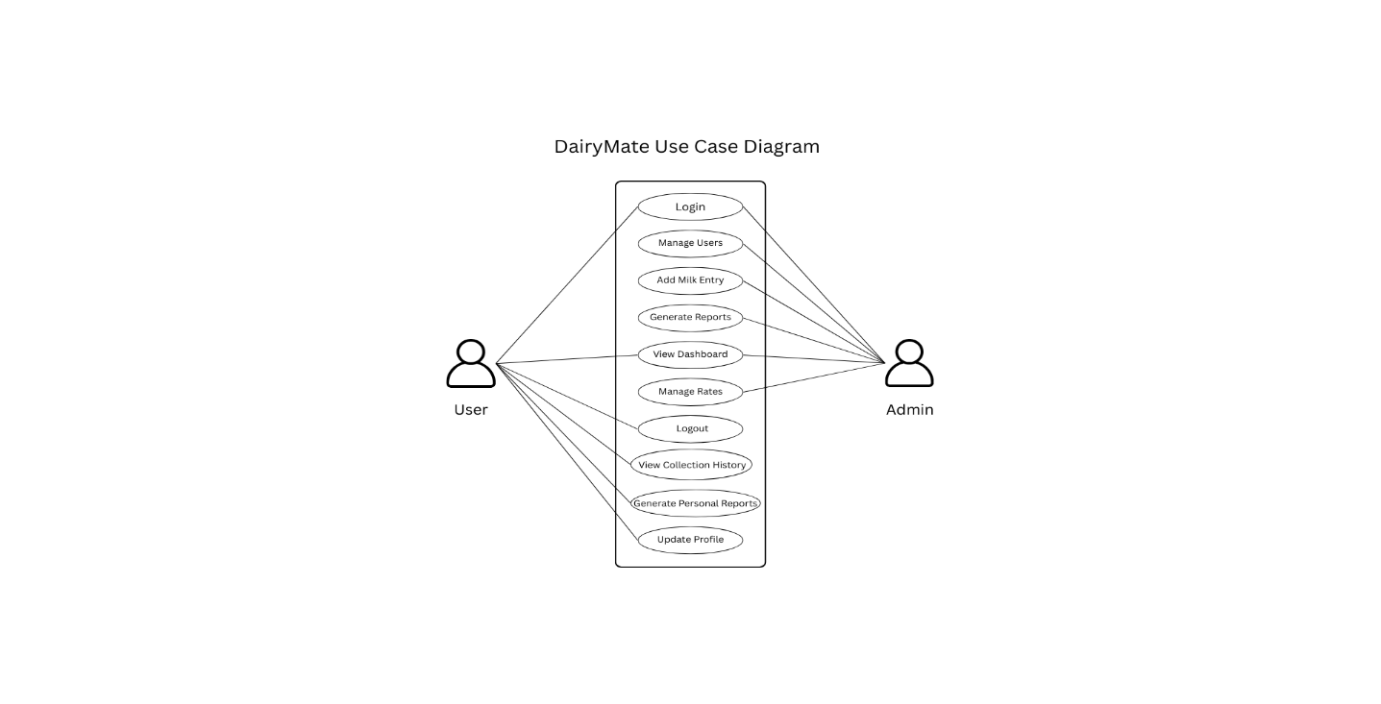

**4. System design**

1. **Architectural Design**

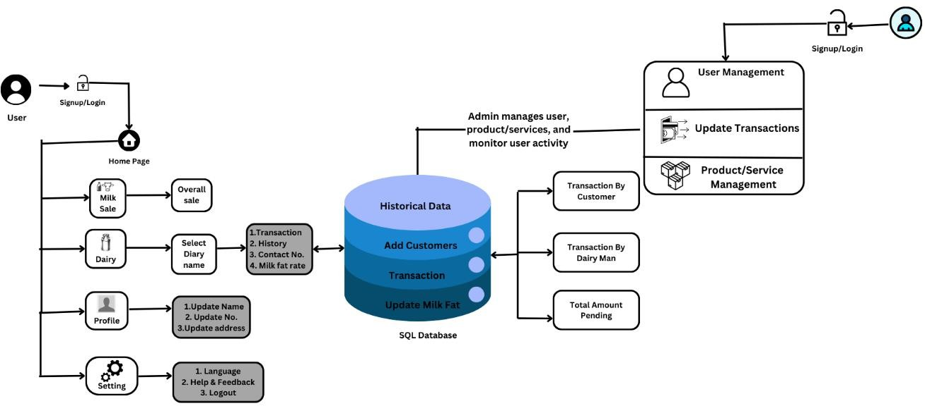

1. **Flow Chart**

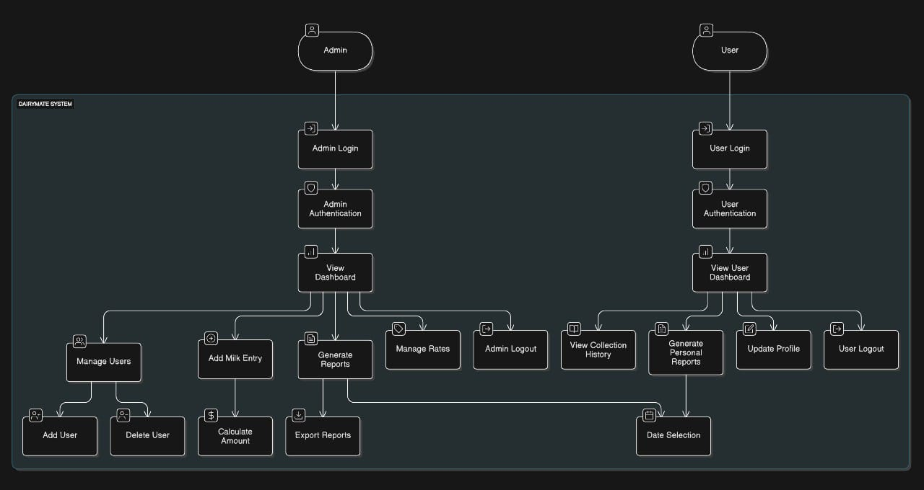

1. **System Modeling**

**Dataflow Diagram:**

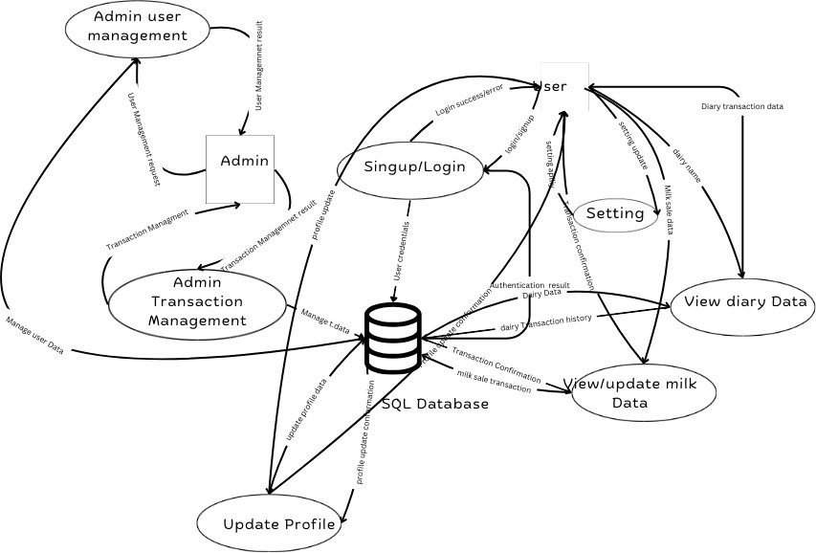

**5. Implementation**

1. **Agile Methodologies:**

The Dairy Mate project follows several key Agile principles and practices:

**1. Iterative Development**

   - Modular architecture with separate components for views, routes, and public assets

   - Incremental feature development and testing

   - Regular updates and improvements based on user feedback

**2. User-Centric Design**

   - Real-time dashboard updates (3-second intervals)

   - Responsive design using Bootstrap 5

   - Interactive features including:

   - Real-time milk collection tracking

   - Dynamic reports generation

   - Profile management system

   - Financial calculations

**3. Continuous Integration Elements**

   - Modern web technology stack (Node.js, Express)

   - Modular code structure

   - Clear separation of concerns

   - Automated data updates

   - RESTful API architecture

**4. Agile Features Implementation**

   - Real-time data synchronization

   - Interactive user interface components

   - Modular component design

   - RESTful API endpoints for data handling

   - Efficient error handling and user feedback

1. **Development Model:**

The project follows a Full-Stack Web Development Model with the following characteristics:

**1. Frontend Development**

   - EJS templating engine for server-side rendering

   - Bootstrap 5 framework for responsive UI

   - JavaScript for client-side interactivity

   - AJAX for asynchronous data fetching

   - Real-time dashboard updates

   - Interactive data visualization

**2. Backend Development**

   - Node.js runtime environment

   - Express.js framework

   - RESTful API architecture

   - Database integration

   - Secure authentication system

   - Data validation and sanitization

**3. Architecture Pattern**

   - MVC (Model-View-Controller) pattern implementation:

   - Models: Data structures and database interactions

   - Views: EJS templates in the views directory

   - Controllers: Server-side logic in server.js

   - Clear separation of concerns

   - Modular component design

**4. Development Stack**

   - Frontend Technologies:

     - HTML5

     - CSS3

     - JavaScript

     - Bootstrap 5

     - Font Awesome icons

   - Backend Technologies:

     - Node.js

     - Express.js

     - RESTful APIs

     - Database management system

**5. Security Implementation**

   - User authentication system

   - Password protection for profile updates

   - Session management

   - Input validation

   - Secure data transmission

**6. Performance Optimization**

   - Real-time data updates

   - Efficient data fetching

   - Responsive design implementation

   - Modular code structure

   - Optimized database queries

**7. Key Features Implementation**

   - User authentication and profile management

   - Milk collection tracking system

   - Financial reporting system

   - Data analytics and visualization

   - Real-time dashboard updates

   - Report generation with date filtering

   - Profile management with security measures

**6. Future Scope**

**6.1 Core Enhancements**

- Mobile app development for Android and iOS

- Advanced analytics with predictive features

- Integrated payment gateway system

- Supply chain management module

- Cloud infrastructure migration

**6.2 Technical Improvements**

- Two-factor authentication

- API development for third-party integration

- Multi-language support

- IoT device integration for milk quality monitoring

**6.3 Business Expansion**

- Multi-location management system

- ERP and accounting software integration

- Automated compliance reporting

- Industry standard integration

**6.4 Innovation**

- IoT-based milk quality monitoring

- Automated milk collection systems

- Smart dairy farm management

- Advanced data analytics

**6.5 User Experience**

- Dark mode support

- Voice command features

- Automated report generation

- Integrated help desk

- Video tutorials and guid

**7. References (public repository GitHub source code links)**

7.1 Source Code Repository

- Project Repository: <https://github.com/NamitPatil/DairyMate>

7.2 Technical Documentation

- Node.js Documentation: <https://nodejs.org/en/docs/>

- Express.js Documentation: <https://expressjs.com/>

- Bootstrap Documentation: <https://getbootstrap.com/docs/>

- EJS Documentation: <https://ejs.co/>

7.3 Development Tools

- Visual Studio Code: <https://code.visualstudio.com/>

- Git: <https://git-scm.com/>

- npm: <https://www.npmjs.com/>

7.4 Learning Resources

- MDN Web Docs: <https://developer.mozilla.org/>

- W3Schools: <https://www.w3schools.com/>

- Stack Overflow: <https://stackoverflow.com/>

7.5 Additional Resources

- Font Awesome: <https://fontawesome.com/>

- jQuery Documentation: <https://api.jquery.com/>

- Bootstrap Icons: <https://icons.getbootstrap.com/>